**An Integrated Remote Sensing and GIS Approach to Identifying and Ranking Landfill Sites for Municipal Solid Waste Management**

***A Report submitted in fulfilment for the degree of B. Tech***

***in***

***Civil Engineering***

***By***

**Mada Akhil Reddy (19241A0131)**

**Pallapu Naveen (19241A0143)**

### Under the guidance of

**Mr. Rathod Ravinder**

**Assistant Professor**

**Department of Civil Engineering**



**GOKARAJU RANGARAJU INSTITUTE OF ENGINEERING AND TECHNOLOGY, HYDERABAD**

**(**Affiliated to Jawaharlal Nehru Technological University**)**

**MAY, 2023**

# DECLARATION

I declare that this project report titled **“AN INTEGRATED REMOTE SENSING AND GIS APPROACH TO IDENTIFYING AND RANKING LANDFILL SITES FOR MUNICIPAL SOLID WASTE MANAGEMENT”** submitted in partial fulfilment of the degree of **B. Tech in Civil Engineering** is a record of original work carried out by me under the supervision of **Mr Rathod Ravinder** and has not formed the basis for the award of any other degree or diploma, in this or any other Institution or University. In keeping with ethical practice in Thesis/Reporting scientific information, due acknowledgements have been made wherever the findings of others have been cited.

Mada Akhil Reddy (19241A0131)

Pallapu Naveen (19241A0143)

# CERTIFICATE

This is to certify that the project report entitled **AN INTEGRATED REMOTE SENSING AND GIS APPROACH TO IDENTIFYING AND RANKING LANDFILL SITES FOR MUNICIPAL SOLID WASTE MANAGEMENT** submitted by **Mada Akhil Reddy, Pallapu Naveen** to the **Gokaraju Rangaraju Institute of Engineering And Technology, Hyderabad,** in partial fulfilment for the award of the degree of **B. Tech in Civil Engineering** is a bonafide record of project work carried out by us under our supervision. In full or in parts, the contents of this report have not been submitted to any other Institution or University for the award of any degree or diploma.

## Mr.Rathod Ravinder Dr.C.LAVANYA

### Assistant Professor Professor

Department of Civil Engineering Head of the Department GRIET Department of Civil Engineering GRIET

**EXTERNAL EXAMINER**

# ACKNOWLEDGMENTS

We would like to express our gratitude to all the people who helped us to transform an idea into a real application.

We would like to be grateful to our project guide **Mr.Rathod Ravinder**, Assistance professor for his technical guidance, and constant encouragement in carrying out our project at college.

We profoundly thank **Mr.Rathod Ravinder**, Head of the Department, of Civil Engineering, who has been an excellent guide and excellent source of inspiration for our work.

We are immensely thankful to **Dr J. Praveen,** Principal, and **Dr J.N. Murthy** (Director), GRIET, who most ably run the institution and have had a major hard in enabling me to do our project

I extended my sincere thanks to one and all of the GRIET family for the completion of this document on the project Thesis/Report format guidelines.

Mada Akhil Reddy (19241A0131)

Pallapu Naveen (19241A0143)

## ABSTRACT

**An Integrated Remote Sensing And GIS Approach To Identifying And Ranking Landfill Sites For Municipal Solid Waste Management**

With the growing urbanization and population growth in emerging nations, where the need for sanitary disposal is essential in managing solid waste on a global platform. One of the major global concerns that are particularly pronounced in developing countries is the disposal of municipal solid waste (MSW). Locating, evaluating, and organizing disposal sites is one of the most important strategies for getting rid of MSW. Hyderabad is one of India's biggest cities. It faces numerous sustainability difficulties and planning issues, such as MSW management. A framework for identifying and ranking landfill sites as well as managing MSW challenges in Hyderabad is being provided in this paper employing Hyderabad as a case study region. This approach can be worked upon and applied to other metropolitan cities. This method can be extended and applied to similar industrial cities. The landfill sites were identified using remote sensing (RS) and geographic information system (GIS).

With the aid of an analytical hierarchy process (AHP), criteria such as distance from populated areas, surface water, open wells, sensitive sites such as community areas, open water channels, protected areas such as ancient landmarks, land use/land cover, geology, type of soil, elevation, hillsides, airport, road systems, and earthquake epicenters were integrated. The methodology uses the analytical hierarchy process to compare the chosen and ranked criteria in pairs. The outcomes display an approximate amount of land for landfill development. It is advised that using the proposed landfill sites would have the minimum negative impact on the environment and public health.

**Keywords: Municipal solid waste, AHP, GIS, Landfills.**

BATCH – B15

MADA AKHIL REDDY 19241A0131 Mr.Rathod Ravinder

PALLAPU NAVEEN 19241A0143 Assistant Professor

Department of Civil Engineering

**TABLE OF CONTENTS**

**DESCRIPTION PAGE NUMBER**

DECLARATION ii

CERTIFICATE iii

ACKNOWLEDGEMENTS iv

ABSTRACT v

TABLE OF CONTENTS vi

LIST OF FIGURES vii

LIST OF TABLES viii

ABBREVIATIONS/NOTATIONS ix

**Chapter 1 INTRODUCTION 1**

## Contour lines 1

## Municipal Solid Waste (MSW) 2

## Municipal Solid Waste in Hyderabad 2

## Chapter 2 LITERATURE REVIEW 5-10

## Chapter 3 EXPERIMENTAL INVESTIGATION/

## METHODOLOGY 11

## 3.1 Data Collection 11

## 3.2 Study Area Description 12

3.3 Methodology To Obtain Elevations 16

3.4Obtaining D.E.M & Contour Maps 18

## Chapter 4 Result 27

4.1 Hyderabad Digital Elevation Model (D.E.M.) 27

## 4.2 Colour graded contour map of Hyderabad 29

## 4.3 Elevation profile of Hyderabad 30

## Chapter 5 Description Of test result 32

## Chapter 6 THE CONCLUSION 35

## 6.1 Scope For Future Work 35

## Reference 36

**LIST OF FIGURES**

**FIGURE TITLE PAGE-NO**

FIG 1.1 Contour Lines 1

FIG 1.2 Contour Maps 1

FIG 1.3 Garbage Yard 3

FIG 1.4 MSW in Hyderabad 4

FIG 3.1 Study Area 13

FIG 3.2 Plugin setup and street map 13

FIG 3.3 Mark of the site by Plugin 14

FIG 3.4 Obtained USGS satellite image 14

FIG 3.5 Map outline of the site from satellite 15

FIG 3.6 Land Use Land Cover Map16

FIG 3.7 Google Earth Pro Image Of Site 16

FIG 3.8 Points Marked On Map Of Site 17

FIG 3.9 GPS Visualizer Mapping 17

FIG 3.10 GPS File To GPX/ Plain Text 18

FIG 3.11 Adding Layers In QGIS 18

FIG 3.12 Delimited Text Layer 19

FIG 3.13 Allocating Saved Map Layer 19

FIG 3.14 Assign Natural Neighbour Tool 20

FIG 3.15 Digital Elevation Model 20

FIG 3.16 Extraction Of Contour From Raster 21

FIG 3.17 Labelling Contour Lines 21

FIG 3.18 Elevated Contour Lines 22

FIG 3.19 Digital Elevation Model 22

FIG 3.20 Obtained Colour Ranges On Map 23

FIG 3.21 Channel Networks And Drainage Basins 23

FIG 3.22 Flow Channels 24

FIG 3.23 Adding Legends and Labels 25

FIG 3.24 Print Of Final Project Map 26

## LIST OF TABLES

Table 4.1 Stream-Order Network In Hyderabad 28

Table 4.2 Colour-Graded Zones On Basis Of Elevation 31

Table 5.1 Result Of Overall Area Of Site 32-34

## ABBREVIATIONS

## AHP – Analytical Hierarchy Process

## ANP – Analytical Network Process

## ASAR – Arid and Semi-Arid Regions

## BIM – Building Information Modeling

## CIM – Construction Information Modeling

## DEM – Digital Elevation Model

## GEP – Google Earth Pro

## GHMC – Greater Hyderabad Municipal Corporation

## GIS – Geographic Information System

## GPM – Global Precipitation Measurement

## MCDA – Multi-Criteria Decision Analysis

## MSW – Municipal Solid Waste

## QGIS – Quantum Geographic Information System

## RFID – Radio Frequency Identification Technology

## RS – Remote Sensing

**CHAPTER 1**

**INTRODUCTION**

**1.1 Contour Lines:**

A contour line is a line drawn on a topographic map to show the elevation or depression of the terrain. A contour interval is the vertical distance or elevation difference between contour lines. Index contours are thicker or more prominent lines that emerge every fifth contour line.

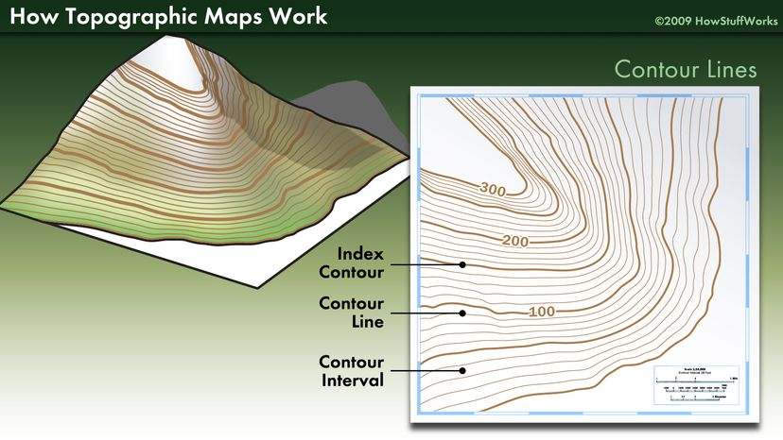

**FIG 1.1 Contour Lines**

Topographic maps only display lines at specific heights. These lines are spaced equally apart. This is referred to as the contour interval. Every sixth contour line is an index contour, which makes topographic maps simpler to read. Because it would be impracticable to indicate the height of every contour line on the map, only the index contour lines are labelled. In comparison to the standard contour lines, the index contours are a darker or broader brown line.

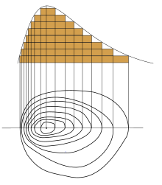

**FIG 1.2** **Contour Maps**

**1.2 Municipal Solid Waste (MSW):**

A clean urban environment is one of the major challenges of the globe, which is at the risk and difficult to achieve mainly due to increased population growth, economic development and urbanization. Hence, it’s the duty of the local government to clean their cities to control municipal garbage. Municipal solid waste (MSW) consists of organic waste, combustible waste, non-combustible waste, ashes and dust, domestic animal wastes, hazardous wastes and construction wastes.

Hyderabad, the capital and largest city of the Indian state of Telangana, is governed by the Greater Hyderabad Municipal Corporation, or GHMC for short. It is the regional administration for the twin cities of Secunderabad and Hyderabad. With a headcount of 7.9 million and 650 km of land, it is one of the biggest municipal corporations in India.

Solid waste has become a global environmental and health issue in the contemporary world both in developing and developed countries. Such environmental challenges combined with social, economic and land availability issues raise concerns over land management and evaluation techniques.

Therefore, locating proper sites for dumping solid waste far from environmental resources, residential areas, water bodies, roads, faults and settlements is essential for the management of solid waste in a proper way. Solid wastes in urban areas mostly include wastes of plastics, glass, fabrics, metals, and kitchen waste which have complex compositions and late degradable characteristics, creating more harm to the environment

**1.3 Municipal Solid Waste (MSW) in Hyderabad:**

Hyderabad produces approximately 5000-6000 tonnes of MSW that is generated every day in the city, 450 to 500 tonnes is plastic waste. However, only 600 tonnes of plastic was recycled in 2017. Moreover, Hyderabad has the highest per capita of waste generation, with the average person in the city producing 5.8 g of waste each day.

All of the city’s waste is then transported to the Hyderabad Integrated Solid Waste Management Project landfill located in Jawaharnagar, where it is recycled or composted, converted into refuse-derived fuel to be sent to cement factories, or ultimately dumped in landfills in large amounts. Landfills present both an environmental and public health risk, endangering thousands of lives. Therefore, this inadequacy in the city’s MSW management system is of critical importance.

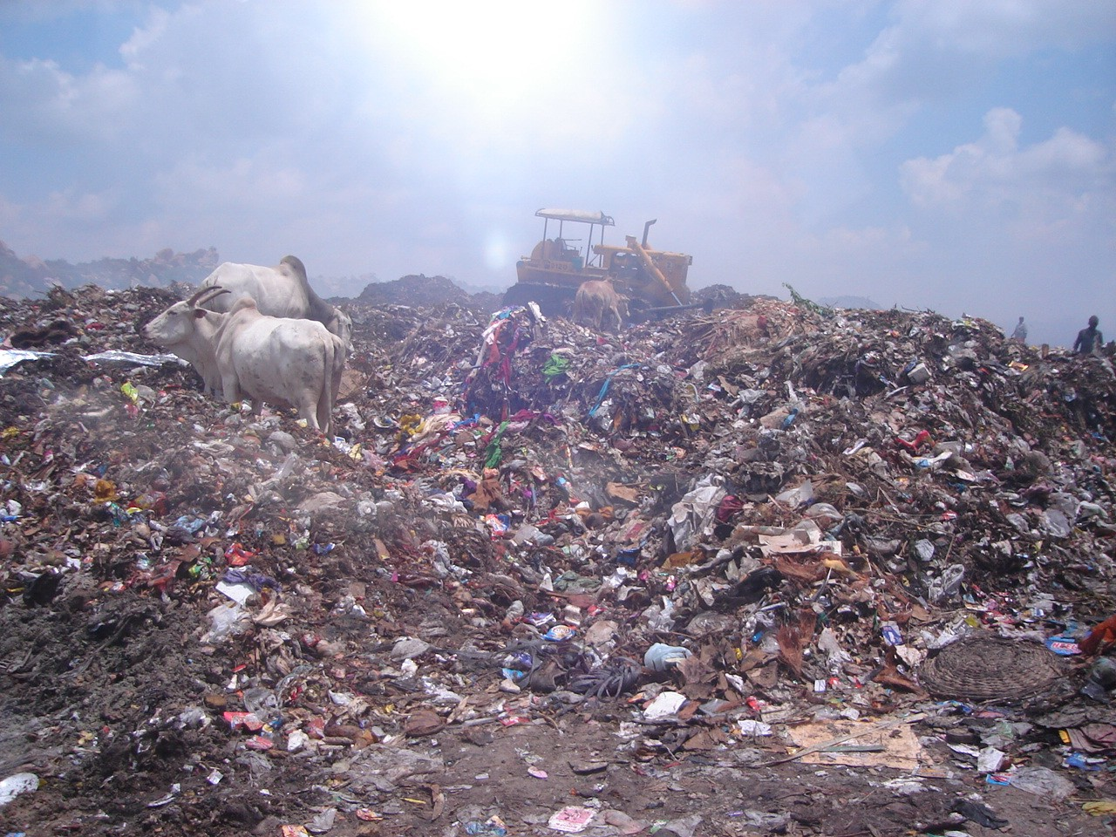

**FIG 1.3 Garbage Yard**

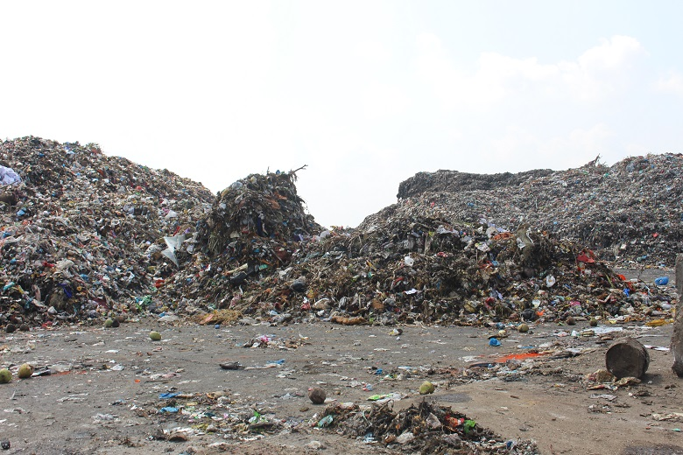

**FIG 1.4 MSW in Hyderabad**

**Hyderabad produces approximately 5000-6000 tonnes of MSW that is generated every day in the city**

**CHAPTER 2**

**Literature Review**

* **(Bilal et al. 2022)** For landfills containing biodegradable waste, suggest that after the organic matter has been degraded, the behavior of the landfill body may converge towards the behavior of a largely inorganic landfill. **(Muhammad Ur Rehman et al. 2022)** conclude that a risk-based needed to determine aftercare completion in view of the conditions at the site and that the aftercare completion cannot be based solely on target values.
* **(Iftikhar Ali and Syed Adnan 2022).** Disposal of predominantly inorganic waste and predictions of the long-term impact of the pilot landfill are based on a so-called source-pathway-receptor approach.
* **(Michael Makonyo et al., 2021)** according to his special attention to waste management is much needed for a clean environment and better human health particularly in the cities of the developing world as they lack the necessary infrastructure for waste collection and disposal activities
* **Mitiku Badasa Moisa, et.al (2021)** researched land use land cover change examination utilizing geospatial methods. It's a contextual investigation of the Geba watershed, western Ethiopia from 1990 to 2020. The classes they pick are agricultural land, dense forest, open forest, settlement and water body. The forest cover is decreased over the review period and agricultural land, settlement land is expanded.
* **Ahmed Z. Dewidar and Hussein (March 2021)** demonstrated that the vegetation (75% of studies), soil quality (75% of studies), weather (56% of studies), and elevation (83% of studies) were utilized as deciding factors in his research on the prospective RWH evaluation by GIS. One requirement or precursor for identifying possible RWH zones is rainfall data, and in theory, a region with more.
* **Tarun Kumar Thakur, et.al (2020)** concentrated land use land cover change location through geospatial examination in an Indian Biosphere Save for the period 2008 to 2018. The components they have contemplated are mixed forest, dense mixed forest, open mixed forest, teak plantation/bamboo break and agriculture. The review uncovers that the woods assets are the principal wellspring of vocation which put extraordinary strain without appropriate forest the executive guidelines
* **Ravi, Swarnalakshmi et. al**. **(2020)** Introduced the idea of a dependable waste management portal that works with other waste collectors and satellite units for the effective and quick processing of garbage in Smart cities. Authorities in charge of waste management utilize the categorization data to promptly alert the quantity of rubbish in the bins. The wastes are divided into four groups by the classification algorithm: moist, dry, normal, and dangerous. Everything can now be remotely monitored thanks to the development of IoT technology, and the combination of machine learning and big data analysis techniques may produce insightful data analysis that can be used to create sustainable solutions.
* (**Shareef et al., 2020)** Classification is the process of organizing and categorizing the different types of land features based on satellite photos and ground truth zones of interest. To categorize the various land cover classes in the research area, we employed the maximum likelihood classification method. According to **Al-doski et al. (2013) and Xu & Wei (2012)**, this method's properties include a regularly distributed individual knowledge through Information of functions of categorization intensity.
* **(Muenchow et al., 2019; Pavlovskaya, 2017)** In response to criticisms of conventional GIS research, one methodological approach called qualitative GIS (QGIS) evolved**.** According to **Cope and Elwood (2009),** "qualitative GIS" refers to "approaches that seek to integrate qualitative forms of data into GIS, develop and support qualitative approaches to building knowledge and explanation with GIS." In this context, the term "qualitative data" refers to information that is not quantifiable and is obtained through the use of text, audio, and visual media **(Flick, 2017)**. GIS methods that emphasize complex meanings and contexts and a deeper understanding of the data are known as qualitative techniques **(Cope and Elwood, 2009).**
* **(Teggi et al., 2018; Heckel & Lemasters, 2011)** Research on the effects of airborne pollutants on a regional-local scale frequently makes use of air dispersion models and GIS (Geographic Information System) methodologies**.** Any third party can create modules in Python and add them to the QGIS **(Lawhead, 2015).** The formats often utilized by GIS (vector objects) and atmospheric dispersion models (tabulated text data) for the input/output data defining sources, receptors, concentrations, and deposition fluxes, however, usually result in significant problems.
* **Amorim (2015)** claims that "CIM is analog BIM in urbanism. It is a system of symbols used to depict urban elements in both a 2D and 3D environment. This was also created using the updated GIS 3D extension, which now has views at various levels and sizes, a design tools, and a list of 3D components and their relationships. Amorim draws the conclusion that adopting CIM can increase the efficacy of urban management since its ideas "look for the general effectiveness of the entire infrastructure system."
* **(William Hogland in 2012).** As long as a landfill represents a hazard and there is a receptor that can be damaged (e.g. human health or environmental media such as groundwater), some level of risk is associated with the landfill. Risk assessment has been applied to landfills, often with a focus on leachate emissions and groundwater pollution.
* **(Hering, 2012),** waste as a byproduct of various human activities creates serious problems in human habitats. Increasing population, rapid economic growth and rise in living standards have accelerated the process of solid waste generation throughout the world.
* **(Scharff et al., 2011)** Directly addresses MSW landfills, albeit in terms of financial risks during aftercare. The other approaches were developed to assess (primarily) the risk of groundwater pollution for largely inorganic landfillsor for model landfills featuring different waste pretreatment options.
* According to **Aazam M. et al (2011),** the number of users who produce waste data, the volume of garbage, and stakeholders all need to be taken into account by waste management authorities. Intelligent waste management is crucial, as is a timely notification of the status of trash collection and analysis of the waste data for all stakeholders. A cloud-based method for smart waste management was presented by Aazam**.** while keeping all of these factors in mind. rubbish bins have sensors built in to let stack holders know how much rubbish is present through a cloud-based network. By calculating the most cost-effective path for garbage collection, this platform aids urban waste management administrations in lowering the cost of waste collection operations.
* **Bottero et al. (2011)** took into account the Analytical Hierarchy Process and Analytical Network Process in choosing the site. **Yal and Akgun (2014)** in Turkey failed to take into account crucial elements including water supplies, metropolitan areas, and soil properties. However, in the current study, an effort was made to utilise all of the case study area's characteristics in order to successfully complete the job that was undertaken.
* According to **Hannan et al. (2011) and Huida et al. (2012),** RFID is a radio frequency identification technology that may be used for solid waste containers. A Web-GIS is a sophisticated tool that can connect to the Internet and do a variety of tasks, including collecting, storing, integrating, analyzing, and presenting information about people and places.
* According to **(Hannan et al., 2011)**, Malaysia could attain complete development by the year 2020**.** As a result, numerous advancements must be made in areas like waste management and monitoring. In this context, it is obvious that pilot projects targeted at creating prediction tools for generated trash estimates, route optimization, truck monitoring, and bin management are essential.
* **Khan and Faisal (2008)** examined the options' relative appropriateness for disposing of urban solid waste by utilizing Super matrices and value judgements of individual decision makers techniques in a study using the Analytical Network Process (ANP). They claimed that ANP is analytically adaptable and helps decision makers identify the ideal resolution for complicated problems by conducting decision issue analysis in the model of an ordered network from many unique terms.
* **(Ghose et al., 2006).** The main element of MSWM to cut costs is route optimization for the collection of solid waste. Without a good storage/collection system or sanitary landfill, a significant portion of the overall expense (85%) is spent on garbage collection alone. According to **Simonetto and Borenstein (2007),** the implementation of an efficient waste management program is a three-step process that includes the following components: (i) awareness campaigns to encourage people to dispose of their waste in the proper containers; (ii) the development of a collection plan; and (iii) waste treatment.
* According to **K.V. Suryabhagavan (2005),** the GIS approach is based on data from an ongoing pilot study regarding the equilibrium is defined as the state when emissions from a landfill occur at a rate that allows sufficient natural depletion in the surrounding environment to prevent environmental harm, so management is no longer required. Consequently, if equilibrium conditions are reached at a site, landfill aftercare can be terminated.
* According to **Andre van Zomeren (2000)** waste is any material discharged from human activities, which makes adverse impacts on human health and the environment. Solid wastes are non-liquid and non-gaseous products such as those from households, municipalities, supermarkets, construction and industries.
* **Guerrero et al (1999),** provided a thorough evaluation of waste management practices in 22 countries across three continents. The study concludes that the processes of trash collection, waste categorization, waste transportation, recycling, and disposal of garbage impact all the stakeholders and variables of waste management systems. For the effective handling of all waste management activities, including notification of the trash quantity and for the recycling mechanisms, intelligence promptly generated insights on waste data, and the authors' emphasis on smart and sustainable solutions.
* **Hipel (1982)** suggested an early design of multi-criteria modelling that included fuzzy set theory to address issues with Canadian solid waste disposal. In order to handle site selection issues in solid waste management, multi-criteria decision analysis (MCDA) has generally been **used (Vuk et al., 1991; Pereira and Duckstein, 1993; Hokkanen and Salminen, 1994, 1997).** In order to assess the suitability of the study region for the best landfill location, **Kontos et al. (2005)** described a methodology that combines several methods from various scientific fields, such as multiple criteria analysis, geographic information systems, spatial analysis, and spatial statistics.

**CHAPTER 3**

**Experimental Investigations / Methodology**

**3.1 Data Collection:**

Selection of potential landfill sites

Download QGIS software & install plugins

Download the satellite data from USGS

Land Use and Land Cover (LULC)

**3.2 Study Area Description:**

The investigation's scope contains Hyderabad is the capital and largest city of Telangana, an Indian state. It covers an area of 650 km2 (250 sq mi) in the Deccan Plateau, along the banks of the Musi River in northern Southern India. Much of Hyderabad is built on hilly terrain surrounding manmade lakes, notably the Hussain Sagar lake, which predates the city's establishment and is located north of the city core. According to the 2011 Census of India, Hyderabad is the fourth-most populated city in India, with a population of 6.9 million persons inside city boundaries and a metropolitan population of 9.7 million residents, making it the sixth-most populous metropolitan area. With an output of US$74 billion, Hyderabad has the fifth-largest urban economy in India.

Hyderabad, Telangana, India has a latitude of 17.387140 and a longitude of 78.491684. Hyderabad, Telangana, India is in the Cities location category and has the GPS coordinates 17° 23' 13.7040'' N and 78° 29' 30.0624'' E.

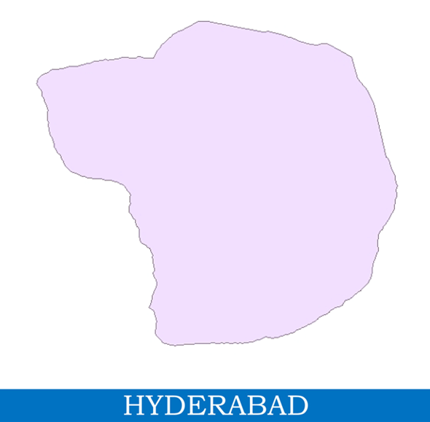

**FIG 3.1 Study area**

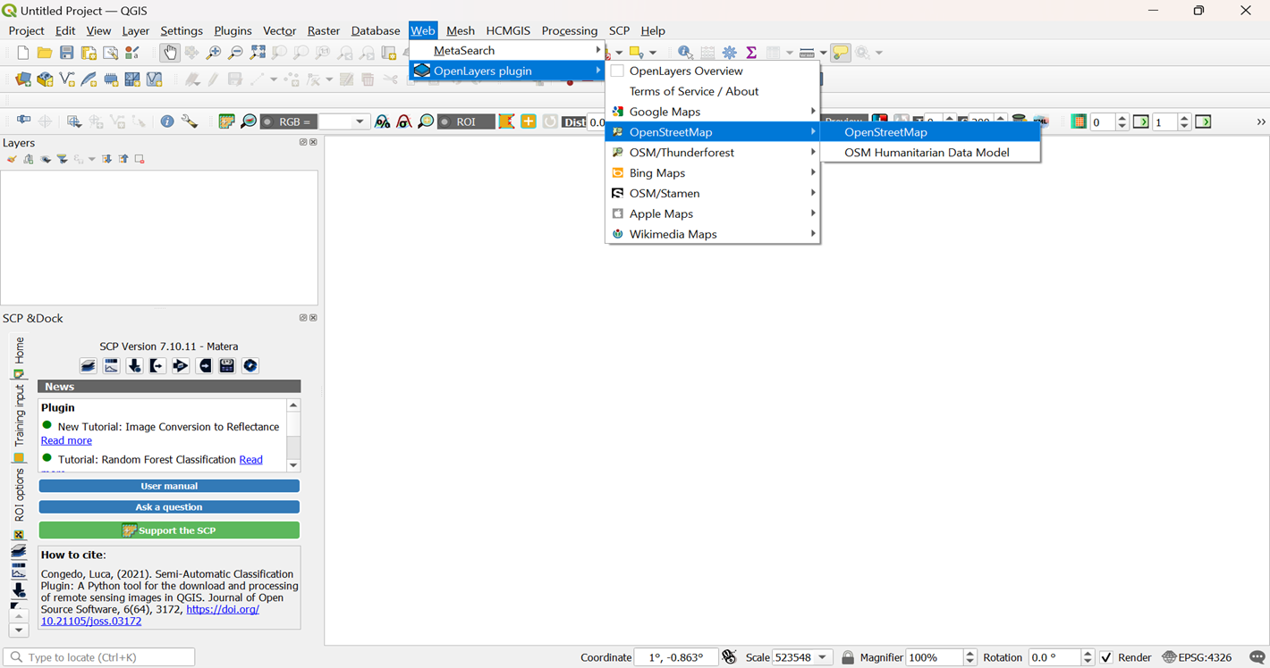

**FIG 3.2 Plugin setup and street map**

Open ‘Web’ and install ‘OpenLayers Plugin’ and open ‘OpenStreetMap’

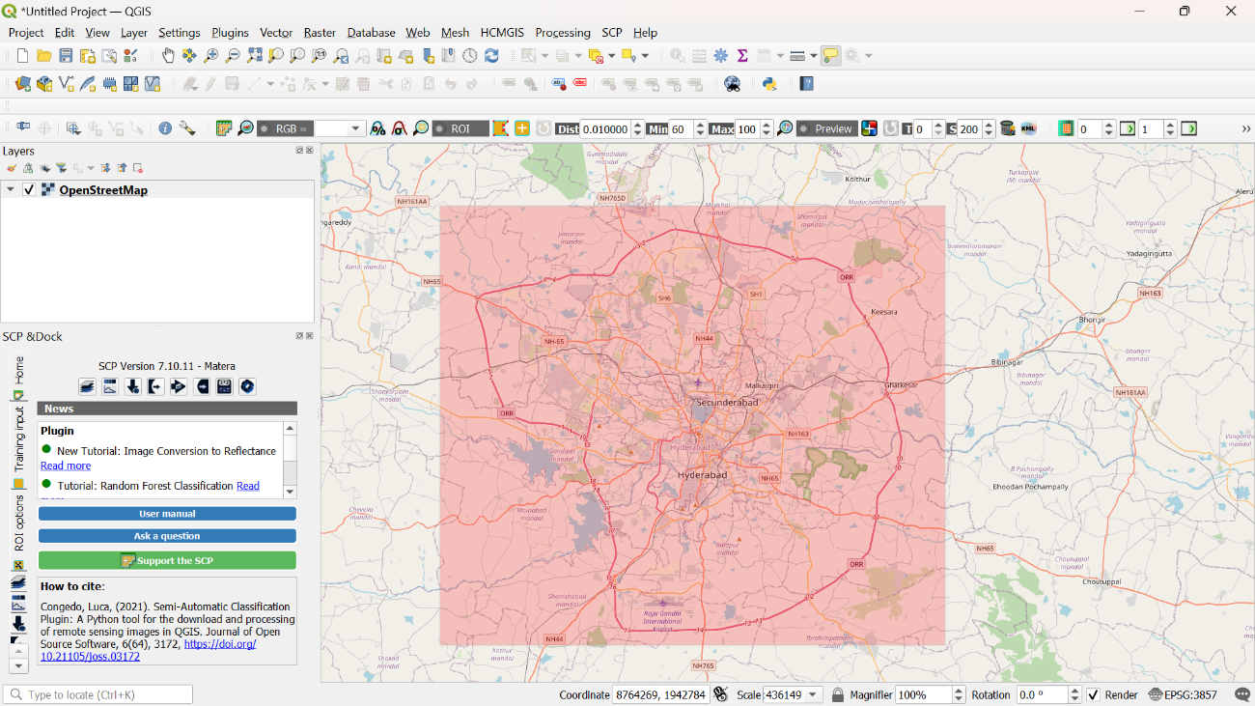

**FIG 3.3 Mark of the site by Plugin**

Install ‘Semi Automatic Plugins’ and open ‘Street Map’ view and mark latitude and longitude and open ‘Semi Automatic Plugins’. Open ‘Download Products’ and assign the latitude and longitude to extract images.

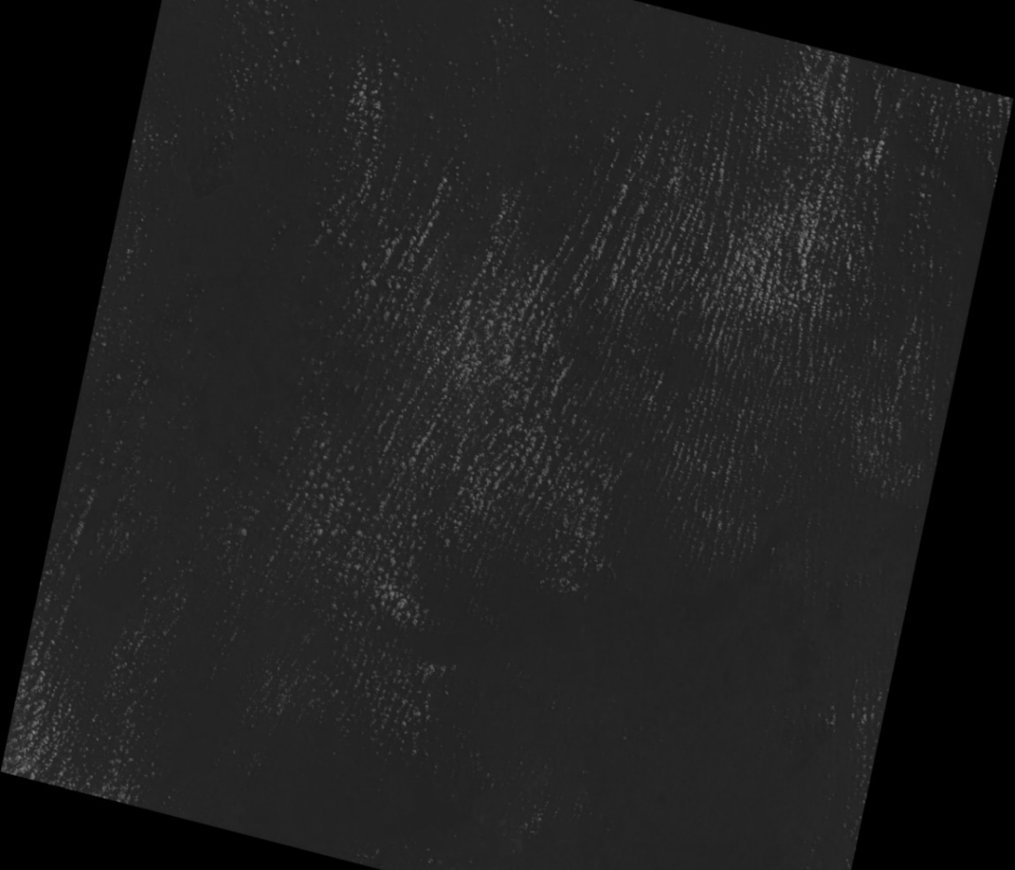

**FIG 3.4 Obtained USGS satellite image**

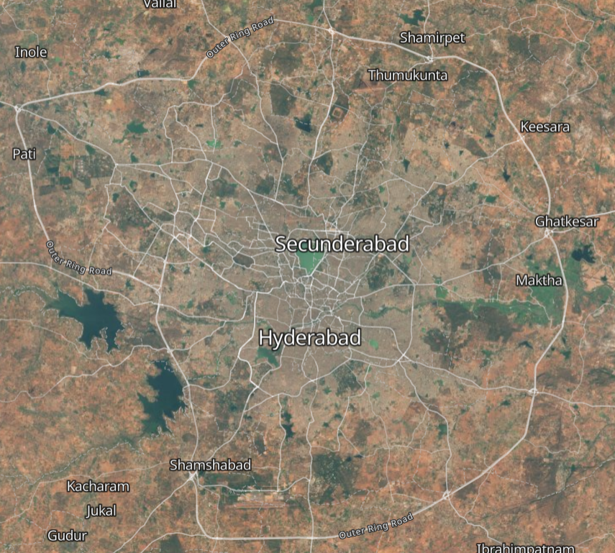

**FIG 3.5 Map outline of the site from satellite**

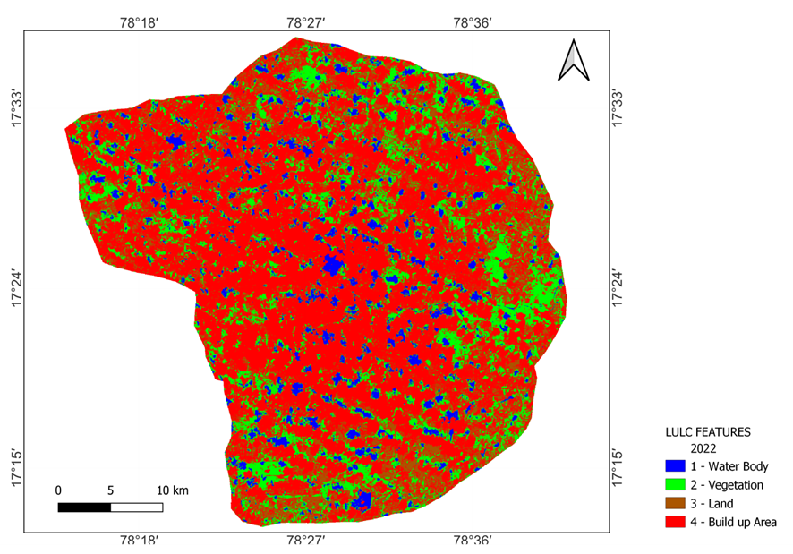

**FIG 3.6 Land Use Land Cover Map**

**3.3 Methodology To Obtain Elevations:**

We utilised Google Earth Pro and GPS Visualizer to determine the altitudes. Screenshots are included for reference. We used Google Earth Pro to generate route lines across the Hyderabad region by selecting "add path."

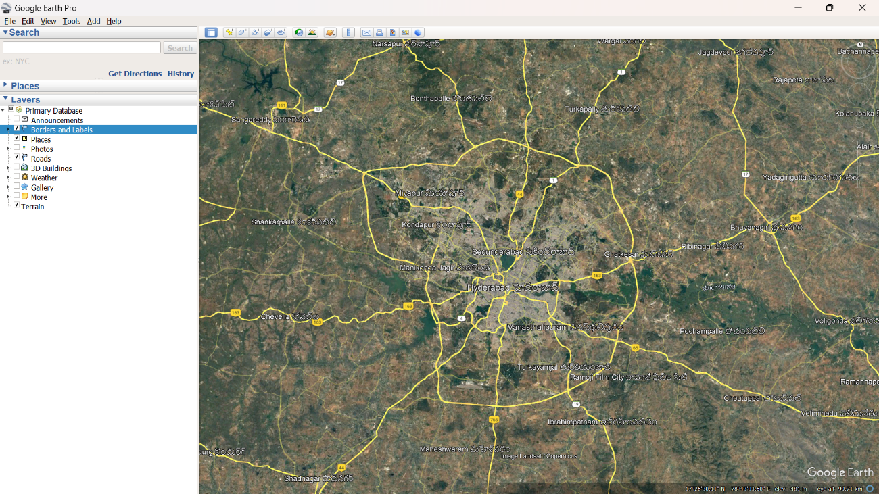

**FIG 3.7 Google Earth Pro Image Of Site**

Assign the file a name and add colour.

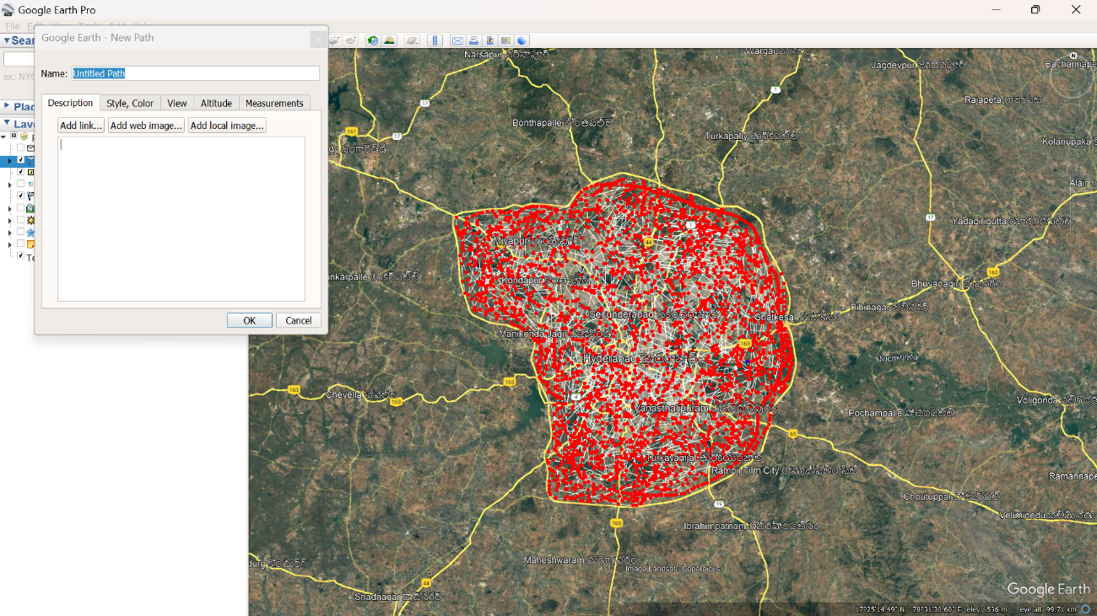

**FIG 3.8 Points Marked On Map Of Site**

Now mark the finite points on the map area for accuracy.

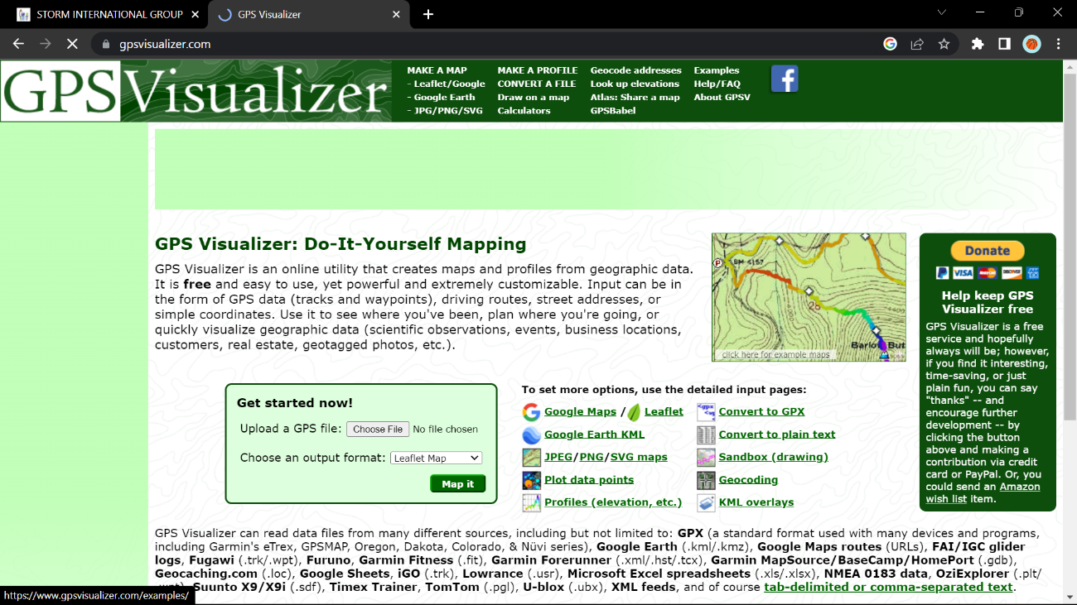

**FIG 3.9 GPS Visualizer Mapping**

After saving the file, launch Google Chrome and navigate to GPS Visualizer. Choose the "look up elevation" option and the file that we saved from Google Earth Pro.

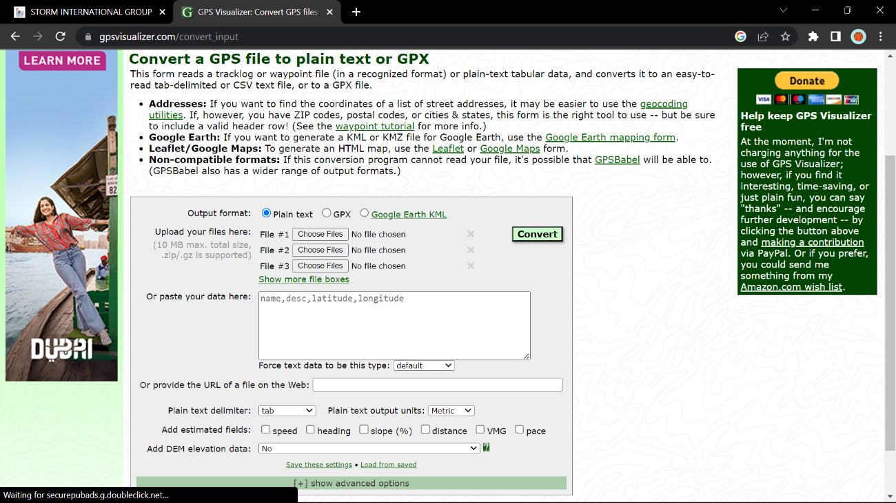

**FIG 3.10 GPS File To GPX/ Plain Text**

After selecting "plain text," click the "convert and add elevation" option.

**3.4 Obtaining D.E.M & Contour Maps**

We utilised the QGIS programme for this investigation. To retrieve the contour lines, we need to import the file that we downloaded from GPS Visualizer. To add the file, go to "layer" and choose "add layer," then "add delimited text layer."

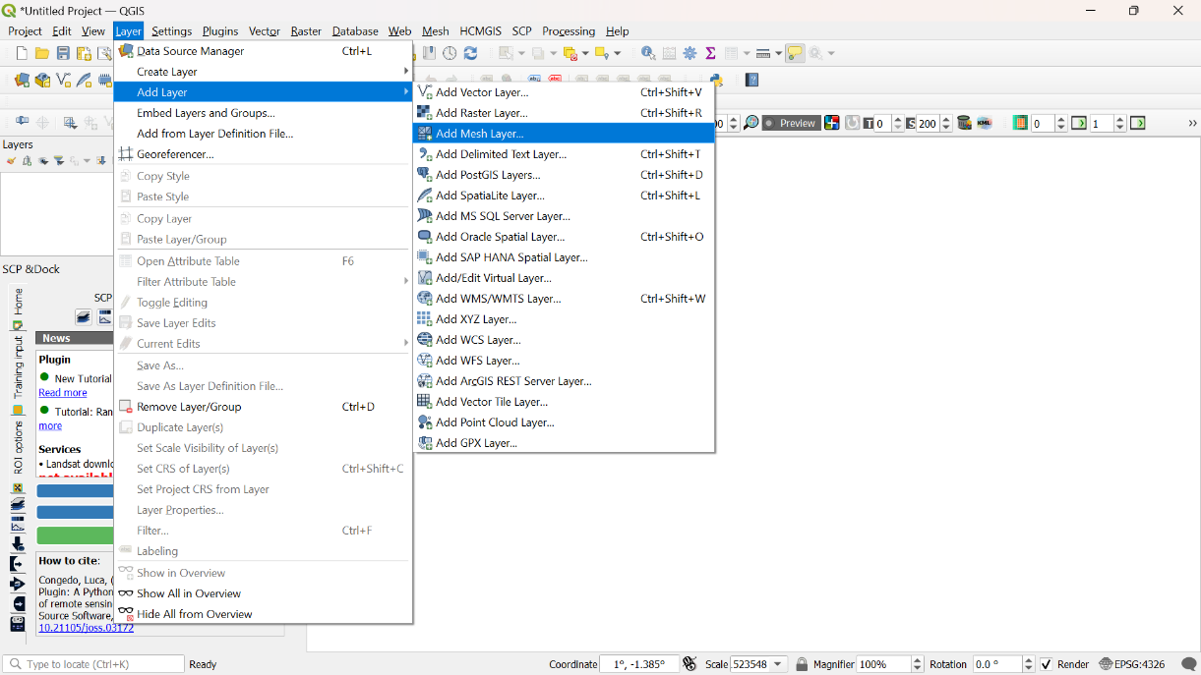

**FIG 3.11 Adding Layers in QGIS**

A window will appear that enables us to pick the elevation file. After selecting the file, press the "add" button.

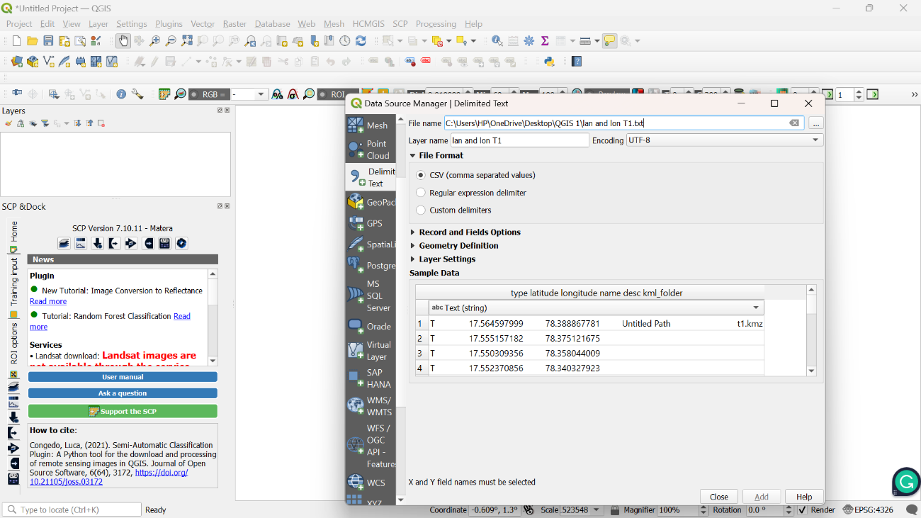

**FIG 3.12 Delimited Text Layer**

The obtained output will be displayed like this;

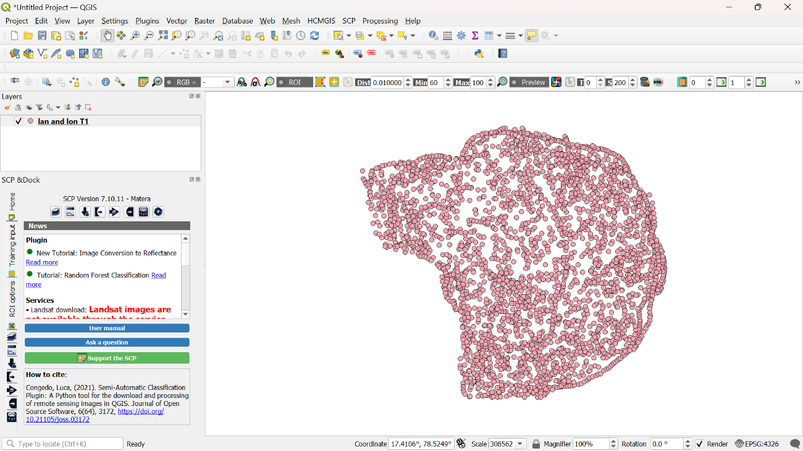

**FIG 3.13 Allocating Saved Map Layer**

On the screen, all of the points will be produced. Now, on the right-hand side, look for "natural neighbour" in the “Processing Toolbox”.

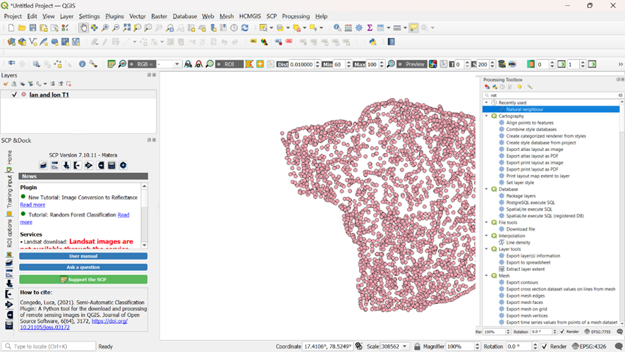

**FIG 3.14 Assign Natural Neighbour Tool**

All of the points will be displayed on the screen. Now, under the processing toolbox on the right, seek for "natural neighbour."

After you've chosen the characteristic, click "run." It just takes a few seconds to complete, and the output is "Digital Elevation Model" under the name of Grid.

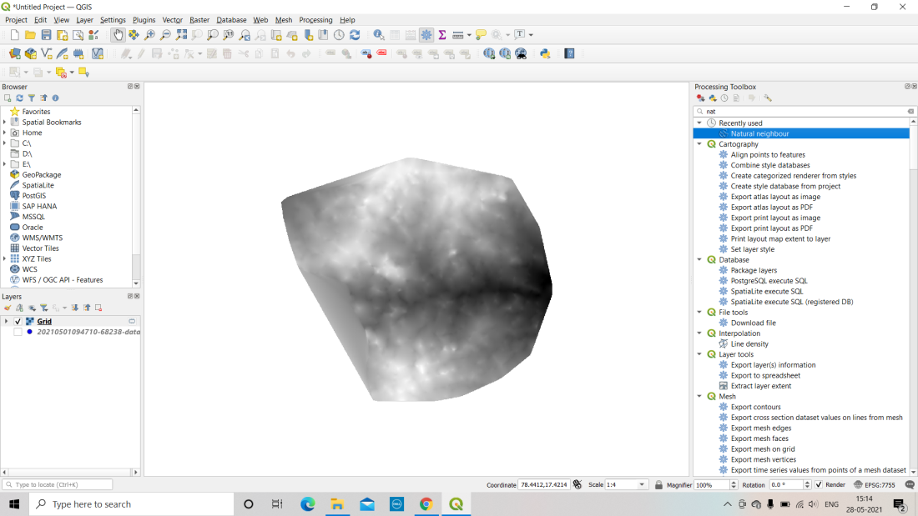

**FIG 3.15 Digital Elevation Model**

This layer is utilised to define the contours of our research area. To obtain contour lines, go to "Raster" and pick "Extraction" and then "Contour."

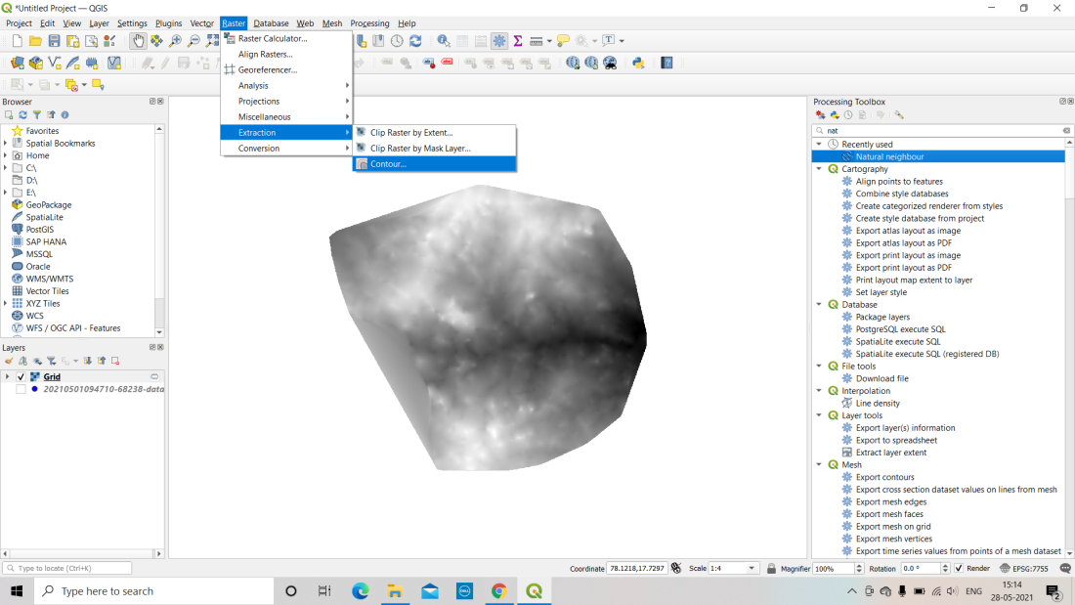

**FIG 3.16 Extraction Of Contour From Raster**

A new window will be launched, and the input layer will be set to Grid.

Set the contour interval as needed for your application; for our project, we set the interval to 1m and named the property "Elevation." Now, click "run" to see the outcome. Depending on the contour interval, it might take a few seconds to several minutes to run. The contour line results for our research region will be presented on the screen.

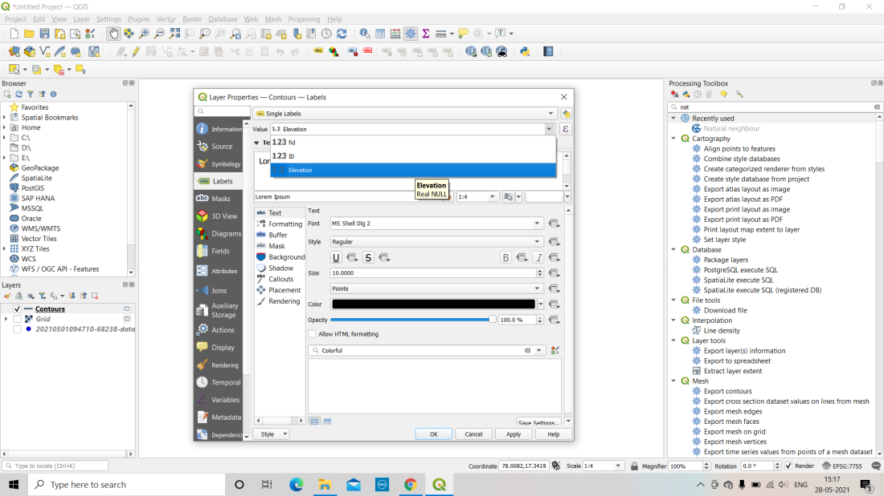

**FIG 3.17 Labeling Contour Lines**

The additional layers will be presented in a window on the left side of the screen. Right-click the "contour layer" and choose properties.

Select "single label" and set the value to "1.2 Elevation" before selecting the size and colour of your choosing. After selecting all of the needed fields, click "apply." The contour map will show the elevation of each contour line.

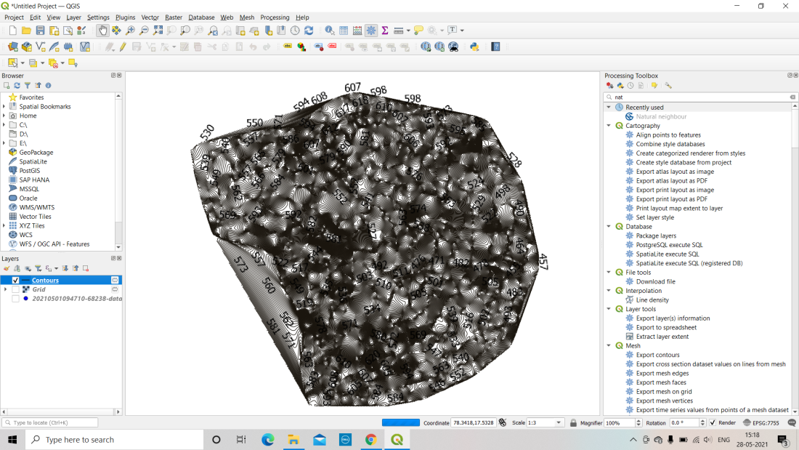

**FIG 3.18 Elevated Contour Lines**

Select "Symbology" to divide the contour into distinct elevation ranges and colour each range of contours separately. Choose "Graduated" and set the value to "1.2 Elevation" before selecting a colour ramp of your choosing.

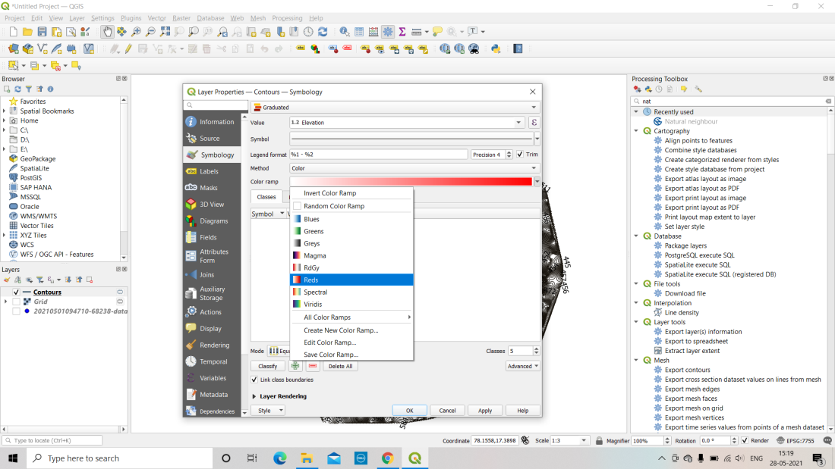

**FIG 3.19 Assigning Colour To Elevation**

Set the number of classes to the number of ranges you desire. Go to mode and set it to equal intervals to split the range of contours evenly. Select "apply and OK." The contour lines will be presented in various colours depending to their range.

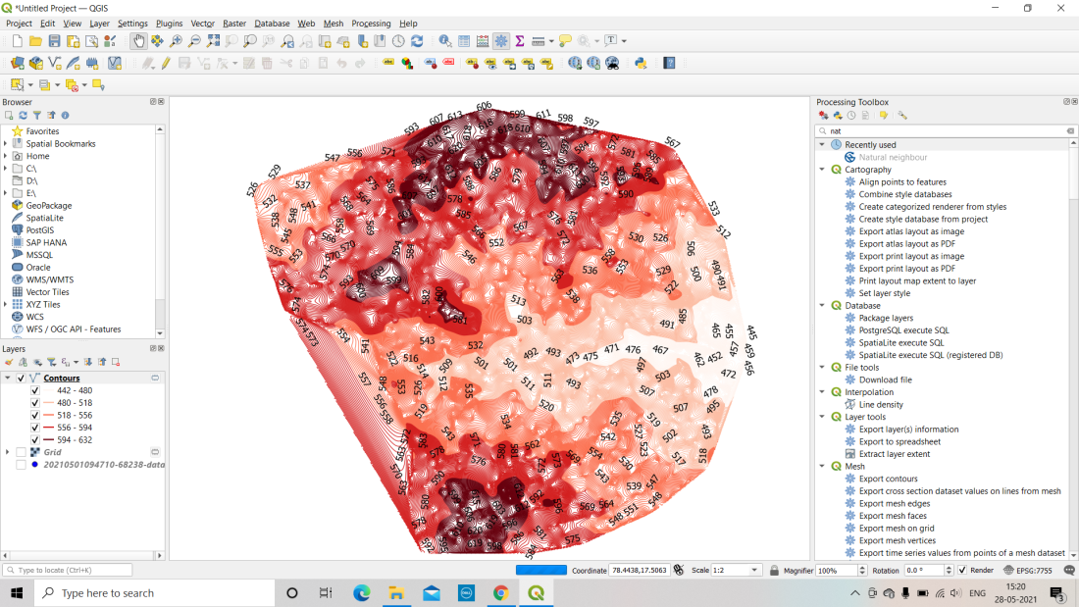

**FIG 3.20 Obtained Colour ranges on Map**

In the processing toolbox, look for "channel network and drainage basin" to acquire the stream's channel and order.

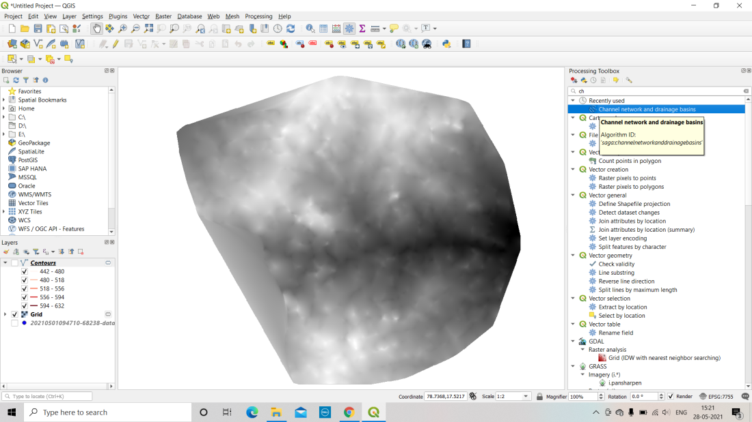

**FIG 3.21 Channel Networks And Drainage Basins**

Choose the option and set the input layer to "grid." Uncheck all settings except channels, as we need the channel streams. "Set the threshold value" to your specifications. Minor streams will be visible if the value is reduced. Now, click "run," and the channels of your study area will be shown in a few seconds.

To retrieve the flow order, left-click on the channel layer that appears on the left side of the screen. Select "single labels" and set the value to "123 ORDER" in the "labels" section. In the labels area, you may also modify the font style, font size, and colour of the order. After you've selected the necessary entities, click "apply and OK." Along the channel, the sequence of the broadcasts will be presented on the screens.

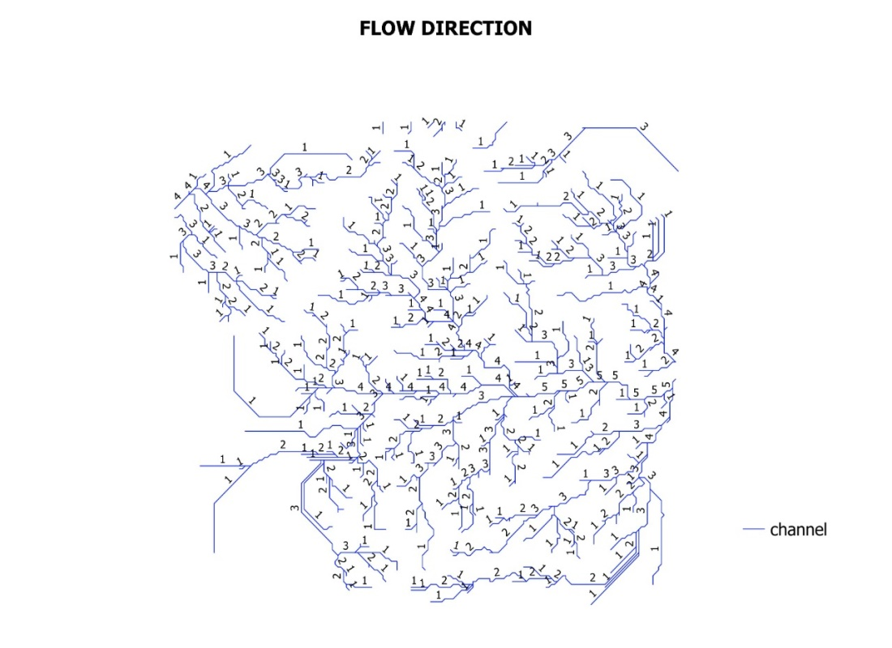

**FIG 3.22 Flow Channels**

To obtain the map, navigate to "project" and then pick "new print layout."

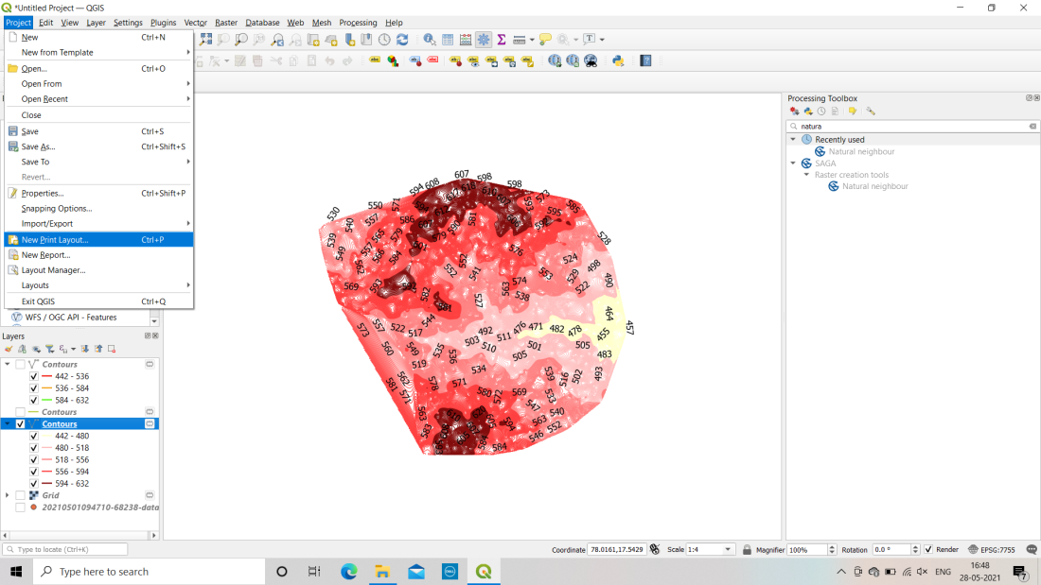

**FIG 3.23 Adding Legends and Labels**

A window will appear where you may name the layout. Give the layout a name and click "OK." A new window will open, allowing us to construct a map of the needed layer. Go to "add items" and then "add label," which is the map's title. Drag the cursor over the place where you want the title to appear. From the item properties on the right side of the screen, you may change the title's name, font style, font size, and alignment.

To add the North arrow, click "add item" and then "add a north arrow." Adjust the size of the arrow by clicking on the region on the map where you want it to be. To add the map, go to "add item" and pick "add map" before dragging the cursor to the place where you want to put the map as the label. Check that the layer for which you wish to make a map is open in the software.

To add a legend, go to "add item" and pick "add legend" before clicking on the map's bottom right corner. On the map, a legend will be presented. If the legend contains a lot of data, tick the box that reads "only show items linked inside map." The legend will now only display data from items located within the map. Adjust the legend's position or location, and our map is complete.

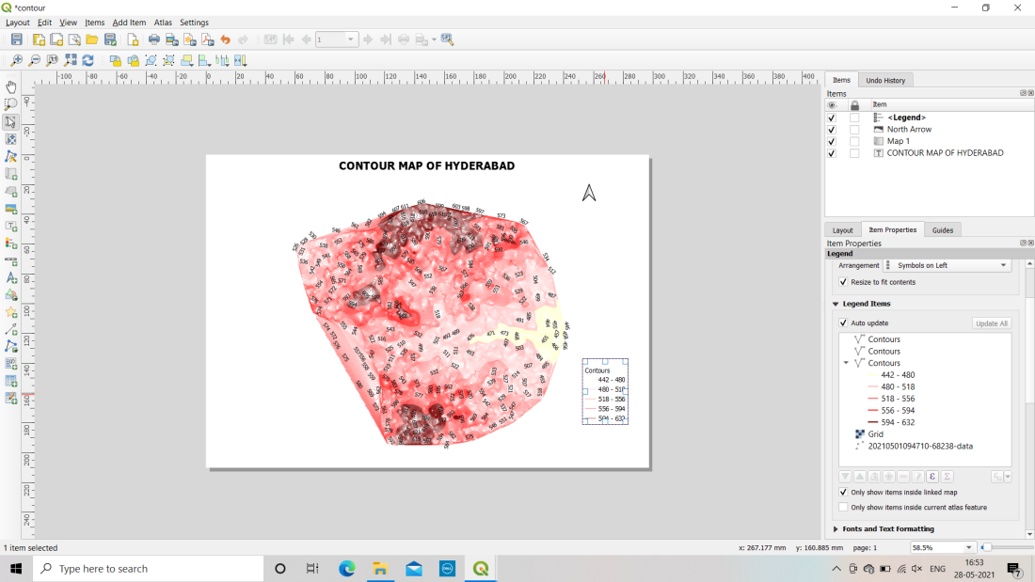

**FIG 3.24 Print Of Final Project Map**

To export the map in PDF or JPEG format, go to "layout" and pick "export map as pdf" (for pdf format) or "export map as image" (for jpeg format), then choose the resolution for your exported picture and click OK. Your map will be stored in the specified folder.

**CHAPTER 4**

**Results**

**4.1 Hyderabad Digital Elevation Model (D.E.M.)**

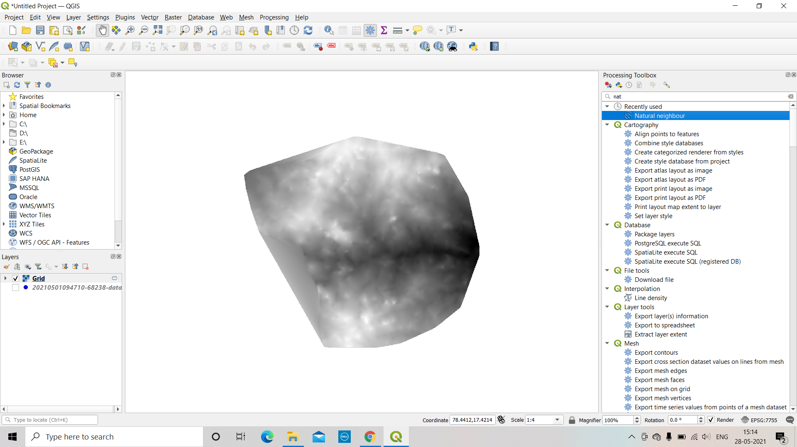

**FIG 4.1 Hyderabad Digital Elevation Model (D.E.M.)**

The computerised Elevation Model (D.E.M.) of Hyderabad is a computerised depiction of the city's elevation data. The dark coloured area symbolises the lower elevation zone, while the light shaded area indicates the higher elevation region.

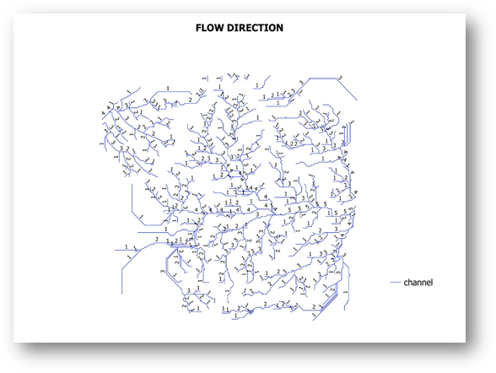

**FIG 4.2 Flow Direction**

Stream order indicates the relative magnitude of a stream. The smallest streams are first-order, whereas the Amazon, the world's largest river, is twelfth order. Headwater streams range from first to third order. More than 80% of the length of the world's rivers is made up of headwater streams. Medium streams are those with orders four through six. Fourth- to sixth-order streams are classified as moderate. A river is a seventh-order or larger watercourse. When mapping stream order, researchers start with the first-order streams in a watershed. First-order streams feed higher-order streams.

When the first order streams have been formed, researchers look for stream crossings. When two first-order streams converge, a second-order stream is generated. A third-order stream is generated whenever two second-order streams overlap, and so on. It is necessary to study the stream network in order to determine geographical indicators.

**TABLE 4.1:** **STREAM-ORDER NETWORK IN HYDERABAD**

|  |  |  |
| --- | --- | --- |
| **S. No.** | **Stream Order** | **No. of Streams** |
| 1 | First Order | 213 |
| 2 | Second Order | 110 |
| 3 | Third Order | 62 |
| 4 | Fourth Order | 28 |
| 5 | Fifth Order | 8 |

There are 213 streams in first order, which is the most number of streams, and 110 streams in second order, which is the second most number of streams. There are 62 and 28 streams in third and fourth order, respectively. Fifth order has the fewest amount of streams.

**4.2 Colour graded contour map of Hyderabad**

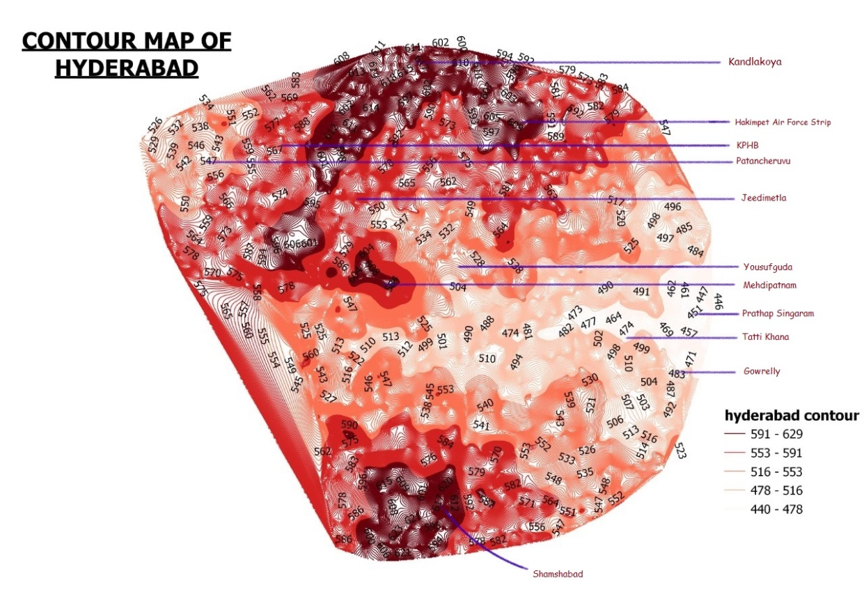

**FIG 4.3 Colour graded contour map of Hyderabad**

A color-graded contour map of Hyderabad with annotated places has been developed. "A contour map is a map that has contour lines drawn on it." The steepness of the ground is shown by contour lines. Contour lines link places that have the same height and are near to one other but never cross." We can see at the map's tip the site KANDLAKOYA, which is in a higher altitude region, and we can recognize a well-known spot in our Hyderabad city, SHAMSHABAD, which is also in a higher altitude region.

**4.3 Elevation profile of Hyderabad**

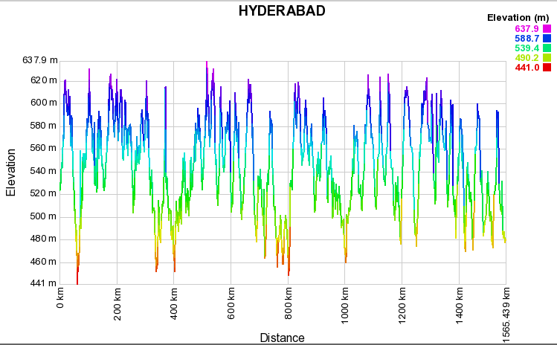

**FIG 4.4 Elevation profile of Hyderabad**

We have established elevation profile of Hyderabad and represented in the form of graph. It is a Distance Vs Elevation Graph. The Hyderabad elevation profile is obtained from GPS Visualizer. We can see that, the elevation of Hyderabad ranges from 441m as its extreme low to the 637.9m as its extreme peak.

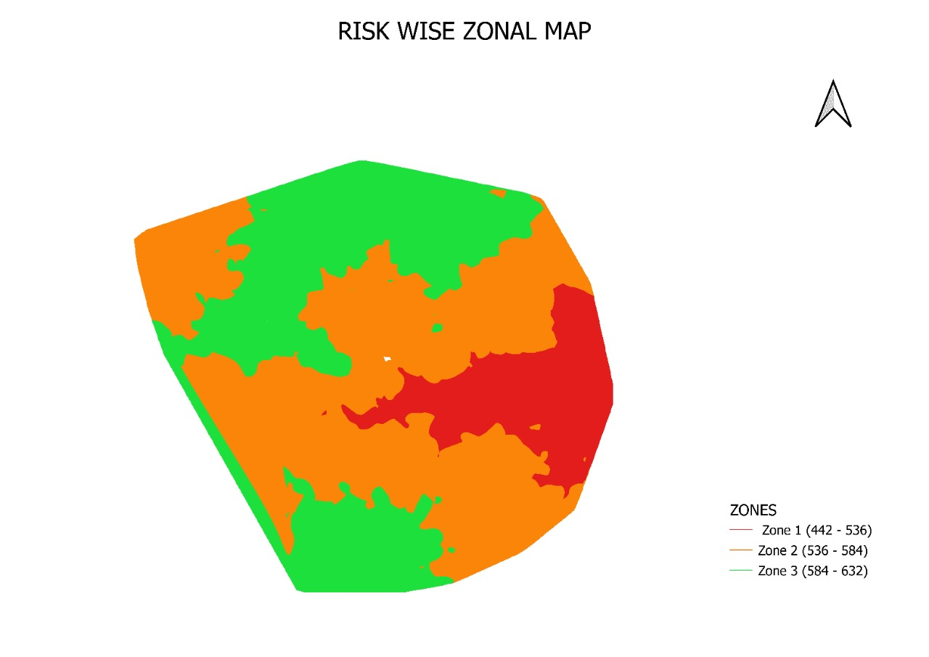

**FIG 4.5 Elevation map of Hyderabad**

The mean elevation of Hyderabad is 536 meters. Thereby, we have considered the datum point as 536 meters and thereby generated the above zonal map.

**TABLE 4.2:** **COLOUR-GRADED ZONES ON BASIS OF ELEVATION**

|  |  |  |
| --- | --- | --- |
| **S.No** | **Zone** | **Range (in meters)** |
| 1. | Green | 632-584 |
| 2. | Orange | 584-536 |
| 3. | Red | 536-442 |

**CHAPTER 5**

**DISCUSSION OF TEST RESULTS**

**TABLE 5.1 RESULT OF OVERALL AREA OF SITE**

|  |  |  |  |
| --- | --- | --- | --- |
| **S.NO** | **ZONE** | **AREA** | **ELEVATION**  **(In meters)** |
|  |  | **Parvathapur** | 461 to 490 |
|  |  | **Nagole** | 473 to 498 |
|  |  | **Pasumamula** | 474 to 485 |
|  |  | **Bandlaguda** | 475 to 497 |
|  |  | **Pedda Amberpet** | 486 to 493 |
|  |  | **Saroornagar** | 497 to 516 |
|  |  | **Auto Nagar** | 483 to 527 |
|  |  | **Rampally** | 488 to 509 |
|  |  | **Hathiguda** | 492 to 516 |
|  |  | **Kuntloor** | 484 to 515 |
|  |  | **Nampally** | 498 to 512 |
|  |  | **Malakpet** | 493 to 503 |
|  |  | **Kharmanghat** | 494 to 516 |
| 1. 1 | **I** | **Hussain Sagar** | 516 to 528 |
| 1. 2 |  | **Begumpet** | 511 to 530 |
| 1. 3 |  | **Dhammaiguda** | 520 to 548 |
| 1. 4 |  | **LB Nagar** | 507 to 516 |
|  |  | **Munganoor** | 504 to 513 |
|  |  | **Thurkayamjal** | 522 to 542 |
|  |  | **Nagaram** | 511 to 535 |
|  |  | **Seetharampuram** | 508 to 525 |
|  |  | **Tarur Village** | 505 to 526 |
|  |  | **Attapur** | 502 to 524 |
|  |  | **Kismatpur** | 525 to 534 |
|  |  | **Hayatnagar** | 502 to 522 |
|  |  | **Charminar** | 518 to 523 |
| 1 |  | **Lal Bazar** | 561 to 582 |
| 2 |  | **Manneguda** | 522 to 553 |
| 3 |  | **Hitech City** | 553 to 617 |
| 4 |  | **ECIL** | 536 to 569 |
| 5 |  | **Sultanpur** | 548 to 547 |
| 6 |  | **Raviryal** | 573 to 581 |
| 7 |  | **Rajendranagar** | 534 to 559 |
| 8 |  | **Jeedimetla** | 554 to 584 |
| 9 |  | **Quthbullapur** | 548 to 557 |
| 10 |  | **Sharmirpet** | 569 to 570 |
| 11 |  | **Serlingampally** | 553 to 578 |
| 12 |  | **Thimmaipalli** | 542 to 559 |
| 13 |  | **Bollaram** | 570 to 598 |
| 14 |  | **Dhulapalli** | 571 to 597 |
| 15 |  | **KPHB** | 567 to 603 |
| 16 | **II** | **Miyapur** | 568 to 572 |
| 17 |  | **Himayath Sagar** | 536 to 568 |
| 18 |  | **Shamshabad** | 565 to 591 |
| 19 |  | **Patancheru** | 532 to 543 |
| 20 |  | **Osman Sagar** | 573 to 590 |
| 21 |  | **Narsingi** | 529 to 545 |
| 22 |  | **Nanakramguda** | 556 to 580 |
| 23 |  | **Balanagar** | 548 to 575 |
| 24 |  | **Manikonda** | 537 to 566 |
| 25 |  | **Mehdipatnam** | 534 to 560 |
| 26 |  | **Golkonda** | 537 to 564 |
| 27 |  | **Adibatla** | 551 to 561 |
| 28 |  | **Balapur** | 523 to 552 |
| 29 |  | **Moosapet** | 542 to 557 |
| 30 |  | **Mallampet** | 559 to 572 |
| 31 |  | **Erragadda** | 550 to 570 |
| 32 |  | **BHEL** | 538 to 578 |
| 33 |  | **Chandrayangutta** | 546 to 576 |
| 1 |  | **Gundlapochampally** | 615 to 618 |
| 2 |  | **Kandlakoya** | 592 to 604 |
| 3 |  | **Bahadhurpalli** | 583 to 605 |
| 4 |  | **GRIET** | 605 to 626 |
| 5 |  | **RGIA** | 591 to 625 |
| 6 |  | **Nizampet** | 588 to 612 |
| 7 |  | **Kondapur** | 585 to 608 |
| 8 |  | **Kompally** | 589 to 598 |
| 9 |  | **Tukkuguda** | 580 to 590 |
| 10 | **III** | **Gollapally Kalan** | 604 to 620 |
| 11 |  | **Devarayamjal** | 594 to 616 |
| 12 |  | **Hakimpet Airforce Station** | 600 to 626 |
| 13 |  | **BITS** | 582 to 607 |
| 14 |  | **Bahadur Guda (Airport)** | 590 to 596 |
| 15 |  | **Gollapally Khurd** | 584 to 592 |
| 16 |  | **Kurmalguda** | 580 to 604 |
| 17 |  | **Jubilee Hills** | 583 to 615 |
| 18 |  | **Banjara Hills** | 562 to 604 |
| 19 |  | **Bowrampet** | 583 to 627 |
| 20 | **Alwal** | 579 to 593 |

**CHAPTER 6**

**THE CONCLUSION**

The areas which are in Red colour are suitable zones for the dumping of Municipal Solid Waste and these areas can relocate the old garbage yards while avoiding environmental difficulties. Solid waste may be easily disposed of at the designated spot.

**6.1 Scope For Future works:**

To summarise, the future of waste management involves converting garbage into energy, IoT-enabled practices, improvements in tracking systems, data collecting, and many other technological breakthroughs.

**References:**

1. Article on “Identifying and Ranking Landfill Sites for Municipal Solid Waste Management: An Integrated Remote Sensing and GIS Approach” by Bilal Aslam, Ahsen Maqsoom, Muhammad Dawar Tahir, Fahim Ullah, Muhammad Sami Ur Rehman and Mohammed Albattah in May 2022.
2. Geographical information systems (GIS) and Multi-Criteria Decision Analysis (MCDA) integration for sustainable landfill site selection considering dynamic data source by Ercument Aksoy & Bekir Taner San in 2017.
3. Identification and selection of suitable landfill sites using GIS-based multi-criteria decision analysis in the Peshawar District, Pakistan by Iftikhar Ali, Aneeza Islam, Syeda Maria Ali and Syed Adnan in August 2022.
4. “Landfill sustainability and aftercare completion criteria Heijo Scharff, Andre´ van Zomeren and Hans A van der Sloot, 18 August 2010.
5. Potential landfill sites selection using GIS-based multicriteria decision analysis in Dodoma capital city, central Tanzania by Michael Makonyo and Michael M. Msabi in 2021.
6. “Solid waste dumping site selection using GIS-based multi-criteria spatial modeling: a case study in Logia town, Afar region, Ethiopia.” by Ahmed Mussa and K. V. Suryabhagavan in 2021.
7. “Solid waste management challenges for cities in developing countries” by Lilliana Abarca Guerrero, Ger Maas and William Hogland in 2012.
8. Swachh Bharat Mission municipal solid waste management manual Part II: The manual Central Public Health and Environmental Engineering Organisation (CPHEEO).